**Game Description**

This game is about time management and building a routine. I want to aim this game towards people who are either grieving, or struggling to build a healthy schedule for themselves. I want to encourage people to find some order in their daily lives that would benefit themselves.

This game will have daily/timed tasks for the player to complete. I want the visuals to, at least, start off soft, so as to not intimidate, or overwhelm them. Tasks may include a mini-game or two, taking care of virtual plants, or walking a certain distance (with a pedometer mechanic). I want to implement a time mechanic that will lightly push a player to manage their time. Failing to complete them in time won’t be too consequential, but completing tasks consistently will increase the reward output. Rewards can include a way to unlock new mechanics or objects to decorate the main screen. This way, the player gets a sense of progression. This will make their screen seem more lively, which will, hopefully, reflect the personal growth the player may be going through. I also want to include a way the player can make their own schedule and checklist, to encourage them to start taking up more proactive hobbies that they, themselves, have picked up.

**Questions and Lens**

Octalysis Framework: Avoidance, Unpredictability, and Empowerment

1) Why is it important that your game transforms players? My game will tackle time management when processing grief. I personally find myself having a hard time managing time during a difficult time, and the lack of productivity makes it difficult to properly process grief as it adds more stress to process beyond grief, slowing down my drive to be productive. I think it would be a good idea to help my audience come up with methods to manage time when they are stuck between a difficult time.

2) What is the ecosystem in which your game must create change? The demographic should be young adults whose day-to-day schedules are always fluctuating and unpredictable. This game can apply to any young adult with a busy life, but I want to specifically target those who are going through the process of grief. Those who have trouble continuing work consistently while managing their own inner turmoil.

3) How should players be different? I don't expect my players to have their problems completely solved, but I do hope they are able to build some time management knowledge that they could use for themselves. I want my game to be a tool of some sorts. A book where players are able to pick up methods in which they can still be productive, while learning to take time to themselves.

4) Why aren't your players already transformed? Grief is a difficult process to get through, which may cascade to unhealthy habits that lets time go by without them being active. One of those habits may be a search to escape to a different reality, which, for me at least, included playing video games. Since my game is obviously a video game, I can use this as a passage from their struggle to getting their work done to giving them knowledge of ways they can traverse their journey of grief.

5) What is essential to include in the game? I think two important topics my game should include is some sort of representation of grief, and time management-based mechanics. I also think "breaks" should be included in my game too, like a suggestion to take a break from the game or an indication that the player should take some time to themselves. This should be able to give off the feeling of time passing by in a low-stakes environment, while telling the player that it is also a good idea to give themselves some time to breathe. Two other features that my game could include, although not necessarily essential, is a mode in which they can build their own schedule with their own tasks that they can use as their checklist, and suggestions on hobbies they could take on, like taking walks or going to the gym.

6) Who knows what you don't know? Therapists and people who had their own experiences with grief.

7) What can you learn from what others have done? I want to research games who tackle the subject of grief, and time management-based games. I also want to look into documents or books that also tackle the same subject, along with the authors' research. In general, I think it would be a good idea to study the process of grief in general to better understand my audience, beyond my own experience. Learning how time-based games use time as a mechanic would help me gauge what level of intensity I should use when it comes to the time mechanic in my game. I don't want my game to add more stress on the player, but I want it to have some sort of push that encourages the player to manage their time within the game.

8) How will you measure your game's impact? This is a tricky question for me, as I find it difficult to figure a way to measure my audience's progression. My best idea is to leave the game open for reviews and comments to see how players react to the game.

**Machinations and Excel**

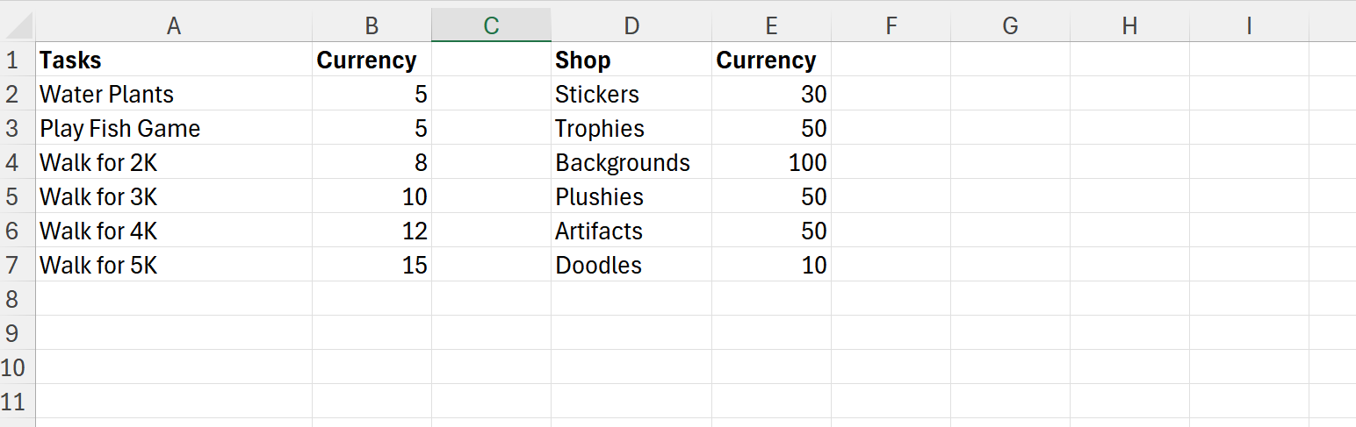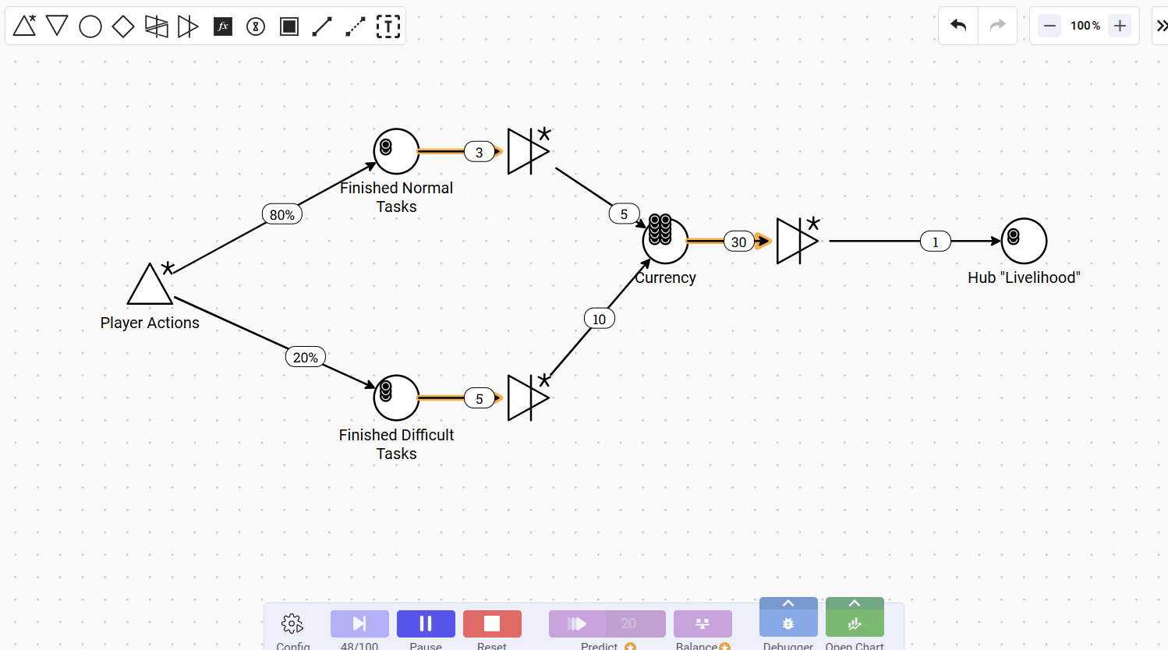

**Interviews**

Question 1: What are your experiences when it comes to mental health or grief?

Kimberly -

Throughout my life, I had a rocky relationship when it comes to mental health. Growing up, I had trouble connecting with a lot of my peers. And nowadays, my mental health gets bogged down by daily life hardships, like schoolwork, my internship, and driving. But I can say, I feel more secure with my relationships with those around me, and the thought of graduating is keeping my spirit up.

Giovanni -

[Prefers to keep this answer private]

Andrea -

Well, as for my mental health, I can say for certain that I have found my own ways to manage it. Sure, I am stressed about finals and my job, as it adds to a lot of my plate this week, but all things considered, I’m feeling alright! As for grief, I can really only say that I only have one experience dealing with it. It took me years to process and accept what had happened, and it sometimes feels as if I’m still grieving in some way, but I’m definitely feeling a lot better nowadays.

Maggaly -

Well, you know. I think Nayeli is still in our minds. It’s still a bit hard to believe that she’s gone. We all miss her, and I’m sure you still do. I have since gone to therapy and my family has helped me a lot through my grief. I still miss her, but I am very happy now.

Mom (rough translation)-

I have lost a lot of people, and it never gets any easier. But I am happy and thankful that I still have my family and my parents.

Question 2: What do you do to process grief or manage your mental health?

Kimberly -

For the most part, I go to therapy and I talk to my friends. I think, nowadays, my busy life is what keeps my mind occupied, despite the stress of it. I also tend to fall back on my hobbies when things get intense.

Giovanni -

I like to hang out with my family and friends. I don’t get to do it as often because of the job I had picked up a couple of months ago. But, when I have time, a lot of my stress gets directed to video games. Hopping on a call with my friends has helped me a lot since I started college.

Andrea -

Music. I have found that music helps a lot when I’m stressed. It’s there when I work, when I travel back home. But also, spending time with my family helps a lot too! Let’s see, exercise, my pets, sleeping, drawing, watching movies, lighting up my scented candles. I can do a lot to manage stress or process grief.

Maggaly -

As I said, I’ve gone to therapy, and that’s my go to. I also like to go out with my boyfriend and listen to a lot of music.

Mom (roughly translated) -

I spend my time going out with my family. I also distract myself by cleaning or watching TV.

Question 3: I am making a game about managing your time during the process of grief or stress, what do you think about it?

Kimberly -

If you do make a game, I hope I can try it out! Although, I don’t think I have much time for it. I used to play Animal Crossing, and that helped me a lot under the pressure of going to a college in the midst of the pandemic, but I had to give it away because I didn’t have time for it.

Giovanni -

I think that would be a good idea if you could pull it off. Although, the way you describe it, it’s less about grief and more so about having routine. Grief is a much more complicated topic. If you have a way to tackle that subject, then I think it would be a great idea.

Andrea-

Well, for me, personally, I find myself not having a lot of time to play video games, but I do know a lot of people who use them as a way to cope during difficult times. I know my dad likes to play games when he’s feeling stressed, and I bet he’d appreciate a game like that. I know that time management is hard to manage under grief, so I think it’s a noble idea to bring some of that concern into a video game for those who are struggling.

Maggaly -

That would be a cool idea! I know I would play it. I remember Nayeli had a game like that. She would always go to it from time to time whenever she seemed stressed.

Mom (roughly translated) -

With a game? I think it’s a better idea to get people to go out or find a therapist to talk to instead. But I know that people like to distract themselves with games. Might be a good idea to use games to teach them about this stuff.

**Storyboards**

